Driven Racing Oil™ Synthetic DCT (Dual Clutch Transmission) Fluid
Huntersville, NC – A new transmission fluid from Driven Racing Oil™ is designed specifically for the needs of dual clutch-equipped vehicles.
Driven’s Synthetic Dual Clutch Transmission Fluid provides the utmost track protection in wet- and dry-style dual clutch transmissions. Like all Driven transmission fluids, it is formulated with advanced synthetic base oils and provides for lower operating temperature, reduced parasitic drag and smooth shifting in high shear racing applications.
Part No. 04606 Price: $16.99

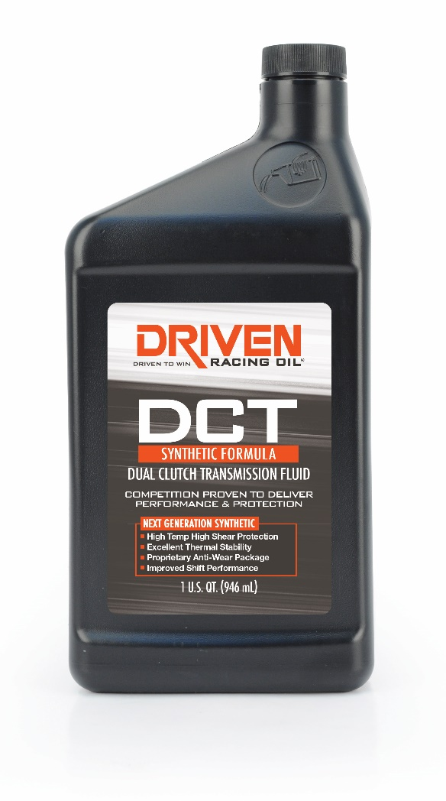

About Driven Racing Oil™
Driven Racing Oil™ utilizes cutting-edge lubricant technology and on-track research for maximum performance gains from all of its product offerings. Competition drives innovation, and Joe Gibbs Racing originally developed the Driven brand of oils to advance engine and driveline performance on the racetrack. From full-synthetic race oils to engine break-in oils and cleaners, Driven offers a wide range of race and street products that deliver performance, protection and value.

